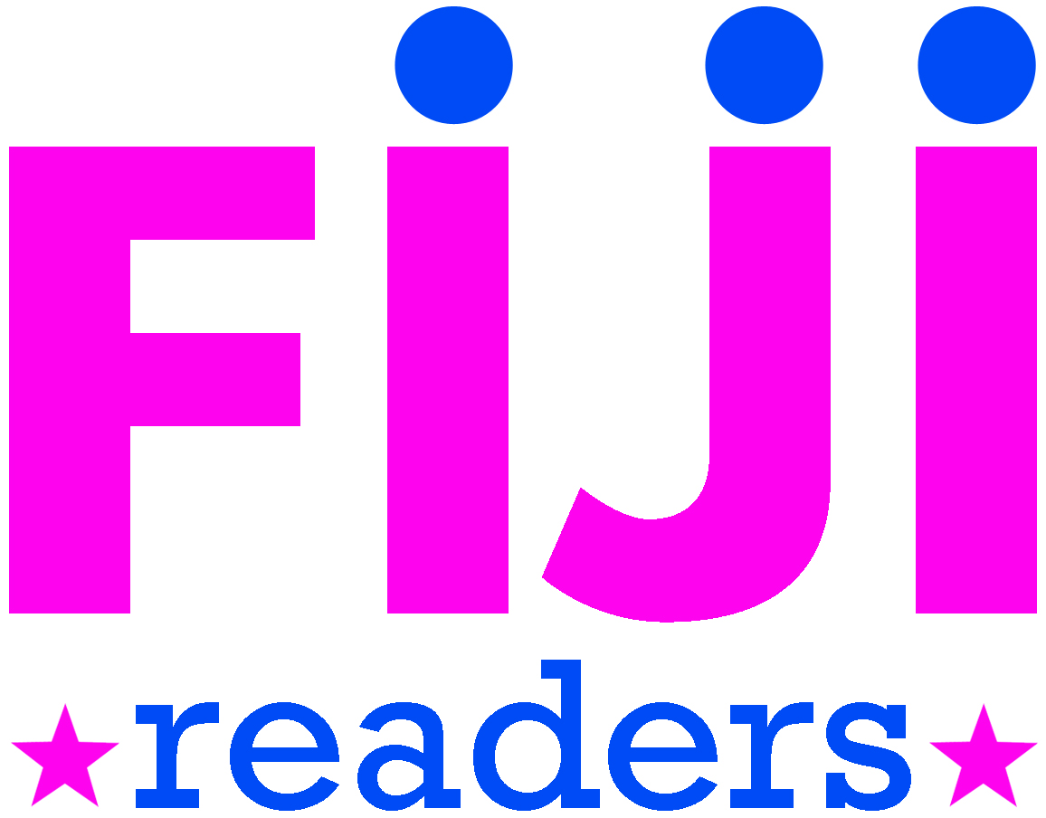
Student Librarian Handbook
Rewards for Student Librarians Are Part of the Job
Student librarians are positive role models for everyone. Student Librarians receive acknowledgement and positive reinforcement from the Principal, teaching staff, the Librarian, and the Library Team. Student Librarians are recognized at assembly and through certificates, awards, and badges, and may receive small prizes (such as stickers, pens, or books) in addition to book-borrowing, photocopier, and internet privileges. And the more that Student Librarians know, the higher their job satisfaction and rewards.

Bronze Level Skills
You must know the library layout
Keep the library in order (furniture in place and rubbish removed)
Tidy library shelves (books upright or some face-out)
Shelve returned books
Choose books for effective face-out display

Silver Level Skills
(includes Bronze Level Skills)
You must be able to issue and return a book
Open and close the library
Check shelves for books in need of repair
Write a review of a new book for display in the library
Read to a group of students at lunchtime
Be a library guide for school visitors

Gold Level Skills
(includes Silver and Bronze Level Skills)
You must be confident in shelving resources in all areas of the library, including doing a shelf check
Deal with overdues and reserves
Be an issuing/returns monitor for a junior class
Use a print reference resource (such as an encyclopedia or dictionary)
Create a display for the library and help change displays
Promote books to fellow students in class or assembly

